AC3 — Page 8, Equation (27) and lines 51–54

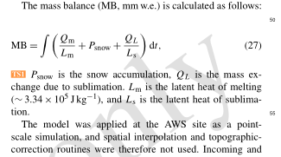

We identified a typographical omission in Eq. (27). The refreezing term, C_en, was inadvertently omitted from the displayed equation.

Please correct Eq. (27) to read:
MB = ∫ (Q_m/L_m + P_snow + Q_L/L_s + C_en) dt

Please revise the explanatory text immediately following Eq. (27) (page 8, lines 51–54) as follows:

“P_snow is the solid precipitation; C_en denotes refreezing; and Q_L is the mass exchange due to sublimation. L_m is the latent heat of ice melt (∼3.34 × 10⁵ J kg⁻¹), and L_s is the latent heat of evaporation/sublimation.”

We confirm that the refreezing term was included in the actual model calculations. This correction only addresses the written equation and does not affect any of the reported results or conclusions.

