At the proof reading stage we made the request that a few values be updated in Table 2 (see screenshot below) ; the updates concern two variables, the nitrogen content of herbage (%N) and the standing biomass before grazing. On these two lines, each comment in purple highlights a change in value that is requested (3 values for %N, 10 values for biomass).

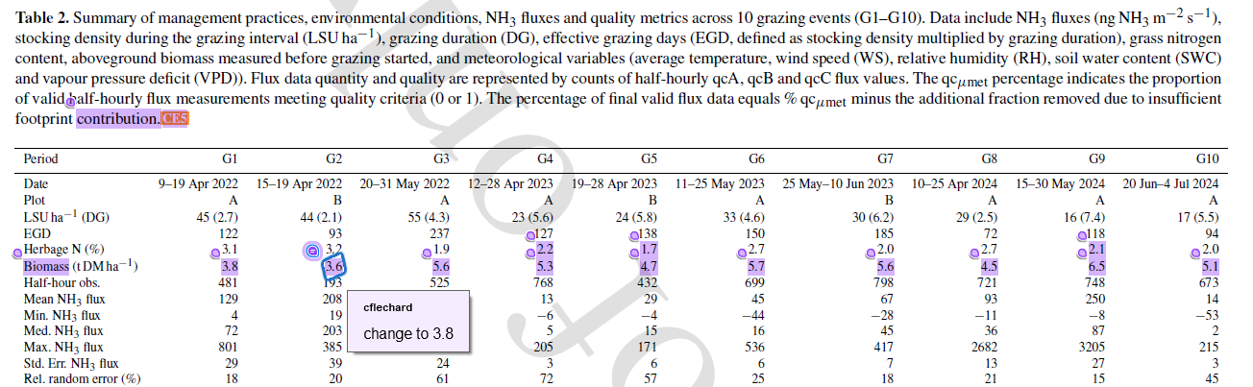

Here is the reason for the requested changes : the values were supplied to us at some stage by partner laboratories in the project. Later on, after the paper was submitted, we realized that the calculation and averaging procedure for the nitrogen and biomass values were biased (for some values) by two factors, 1- a contamination by dirt of grass samples taken very close to the soil, and 2- an inexact value of the grass height within the sampling quadrats. But it was possible to quantify and correct for the biases by re-analysing the data, excluding some samples and recalculating correct average values.

We therefore thought it good scientific practice to provide updated/corrected values, as far as we could tell, even if they differed from the original values that we first submitted : it would be misleading to the readership to leave some values in the paper with the full knowledge that they are biased.

But importantly, as Ivonne knows, these are two ancillary variables (metadata) that are used to document the state of the grassland ecosystem, and may be used a posteriori to try and interpret the variations in the main variable of interest in the paper (the NH3 emission fluxes), but as such these two ancillary variables do not impact the results of NH3 flux measurements that we made on the field.

Nonetheless, because towards the end of the paper we provide emission factors (EF) based on excreted nitrogen, which is calculated on the basis of the nitrogen content of the grass, the original bias in %N in grass propagates in the EF values for excreted N. Therefore, to be completely consistent, we argue that we should update the values not only in Table 2 (as shown above), but also in Table 3 and in Table 4, and in one or two places in the text. This can be done very quickly, we will supply the updated values for Tables 2,3,4 within a day if you agree to the correction procedure.

Please note that the magnitude of the change in EF values is of the order of less than 10%, significant but not massive. Ammonia EF per cow head will not be affected ; and no figure needs updating. The adjustments will not change the conclusions of the paper.

