Changes for Text on Current Typeset Pages 25 and 26. There is a new Figure 16 to be added *after* Fig. 15 (formerly Fig 14) currently on page 27. Changes on pages 25 and 26 are too many and messy to insert or delete on typeset pages. Thus, I copied the text on those pages, as typeset. Noted with strikethroughs and yellow highlights for additions, the typeset text modifications are as follows:
Page 25 - typeset Lines 7, 9, 10, 13, 14, 18, 27, 37, 41. Page 26, changes to typeset Lines 4, 5, 26, 38, 47, 60

(Boynard et al., 2025). Note that the latter study only spans 2008–2023, much less than the SHADOZ data but close to the OMI/MLS period, 2005–2023.
The tropical trend study of Gaudel et al. (2024) groups 5 SHADOZ and IAGOS profiles somewhat differently from this study and only extends through 2019 (period of trends are shown in the fourth column of Table 6). Our trends and those of Gaudel et al. (2024) for FT ozone and TrCO (Table 6; Fig. 16a) over the Equatorial Americas are similar, although some are insignificant. The Equatorial Americas FT ozone trends range from (−0.01 %)/decade to (−3.3 %)/decade. For TrCO_{sonde}, derived from profiles, the range is (−1.0 to −3.1) %/decade in between the satellite-based trends: . They are (3.1 ± 2.5) %/decade for OMI/MLS (2005–2023) and (−4.0 ± 1.0) %/decade for IASI/Metop (2008–2023), an offset of 7.1 %/decade for the median trends. Within given uncertainties, IAGOS, IAGOS-SHADOZ-combined and IASI/Metop agree (Fig. 16b) their trends all slightly negative.
For the Atlantic and west Africa regions, the profile-based comparisons differ in station-airport combinations among our study, Gaudel et al. (2024) and the two HEGIFTOM analyses. The FT and TrCO trends among the four studies (Table 6, Figs. 16a and 16b) fall in a relatively small range: (−1.3 ± 2.8) %/decade (FT, Gaudel et al., 2024) to (1.9 ± 1.8) %/decade (TrCO, this study). The larger TrCO from the Natal–Ascension com-bination appears to result from a higher positive trend in the UT (3.4 ± 2.9) %/decade (Fig. 16c). Because the FT ozone trend of Gaudel et al. (2024) is negative and the Nat-Asc FT ozone trend is positive (Table 6), combining western African IAGOS profiles with the Natal and Ascension measurements, reduces the larger area trend compared to the sonde-only FT ozone trend. Table 6 shows that for all regions the MLS-derived UT ozone trend estimates fall between +3 %/decade and +4 %/decade (Froidevaux et al., 2025). Only over the Atlantic region do any of the SHADOZ UT ozone trends fall in this range. Overall, the Atlantic and West Africa FT ozone and TrCOsonde trends are (0-2) %/decade nearly zero, in agreement with OMI/MLS (1.3 ± 1.4) %/decade. As for the Equatorial Americas, the 2008–2023 trends from IASI/Me-top over the Atlantic and west Africa are much lower:(−4.9 ± 2.0) %/decade. Compared to the OMI/MLS trend, the IASI/Metop median trend has a 6.2 %/decade low bias. The picture for east Africa (both SHADOZ and IAGOS profiles over Nairobi) is similar to the Atlantic and west Africa. FT ozone, TrCO_{sonde} and OMI/MLS TrCO trends are essentially null (Table 6, Figs. 16 a and 16b), similar to HEGIFTOM-1, but IASI/Metop displays a (−3.6 ± 1.0) %/decade trend.
There is more variability in trends among the ground- based studies for the equatorial SE Asia region than the Equatorial Americas, Atlantic and Africa, most likely because different combinations of IAGOS profiles and SHADOZ data were used. Supplementing FT KL-Java SHADOZ profiles with IAGOS data (Tables 3 and 6) in our study, a 50 % increase in sample size, did not change the trend appreciably: (1.0 ± 2.6) %/decade vs (1.6 ± 3.2) %/decade. The corresponding TrCO_{sonde} over KL-Java increased (2.6 ± 2.3) %/decade. S24 computed trends with MLR for KL-Java for 1998–2022: the TrCO_{sonde} was (3.4 ± 2.6) %/decade. Although the trend period only differs by 1 year, the smaller trend with the extra year in this study (to 2023) might reflect some COVID impact (columns 5 and 7 in Table 2). For OMI/MLS TrCO, determined from a mean of changes averaged over 5°×5° grid boxes for KL and Watukosek (Java), there was a trend of (5.6 ± 6.0) %/decade, 2005–2023. The latter change is nearly the same as Gaudel et al. (2024) for both FT ozone and OMI/MLS changes over the same interval. There are several reasons that Gaudel et al. (2024) FT ozone trends in Table 6 and Fig. 16b are larger than our SHADOZ-IAGOS FT ozone trends. First, the fusing of SHADOZ and IAGOS profiles in Gaudel et al. (2024) may be more heavily weighted to polluted IAGOS segments than our merging. Second, reprocessed IAGOS profiles have not been rigorously compared to SHADOZ data up to this point; a new evaluation of IAGOS instrumentation in the World Calibration Center for Ozonesondes may facilitate consistent refer- encing to an absolute ozone standard in the future (Smit et al., 2024, 2025). Third, with the shorter trend period, especially ending in 2019, the data of Gaudel et al. (2024) would not be affected by lower, COVID-perturbed ozone concentrations in 2020–2023 as some SHADOZ records arewere (Table 2).
The HEGIFTOM-1 FT ozone trend (2000–2022) for Kuala Lumpur is nearly identical to the KL-Java trend, 1998–2023: (2.2 ± 3.0) %/decade. In HEGIFTOM-2 (based on SHADOZ KL and IAGOS from several SE Asia airports) FT ozone increases over a longer period (1995–2022) are (6.2 ± 2.2) %/decade. Thus, in general, over SE Asia, as for the

Proof Page 35
Equatorial Americas, Atlantic and Africa, the GB and OMI/MLS trends are in reasonable agreement, given some differences in data selection and minor differences in the trend start and end dates: FT and TrCO ozone increases ∼ +(2–8) %/decade. Likewise, the IASI/Metop trend for TrCO, (0.0 ± 1.4) %/decade over 2008–2023 (Boynard et al., 2025), is an outlier over SE Asia.
Nowhere are the satellite data as divergent from the FT sonde trends, near zero change from our study (1998– 2023) and Gaudel et al. (2024, for 2004–2019) and HEGIFTOM-1 (2000–2022) than at Samoa (Table 6). TrCO from the SHADOZ sondes has no significant change: (−1.4 ± 4.8) %/decade, this study); (−3.1 ± 5.4) %/decade (Gaudel et al. 2024). However, the OMI/MLS trend for TrCO is (9.1 ± 8.3) %/decade, 2005–2023, and IASI/Metop
is (−9.0 ± 1.7) %/decade (Fig. 16a). The large disagreement in trends from sondes and both satellite instruments, the latter with median TrCO trends that are offset by 18 % from one another, underscores the need for profile-based tropospheric ozone trends as an unbiased reference.
End of Section 4.2 at line 4 on typeset page 28
Resume edits on typeset Proof page 28
>>>>>>>>>>>>>>>>>>.
NEW ORDERING OF FIGURE CAPTIONS *AFTER* FIGURE 8 (new Figures in highlight)

Figure 9. Summary map of the annual 1998-2023 MLR trends for five T21 SHADOZ sites for the total tropospheric column ozone (TrCO), surface to tropopause, in %/decade from Table 2 including the 95% confidence intervals.

Figure 10. (former Fig 9) (a) Monthly MLR trends (colored dots) derived from SHADOZ T21 stations highlighting a July-October decrease in LMS ozone in 15-20km layer; yellow dots denote the mean of all T21 stations, with error bars indicating the 95% confidence intervals. (b) Corresponding TH trends (380 K potential temperature; θ) derived from the radiosondes. (c) Same as (a) except trends have been computed for the segments between the tropopause and 5 km above the TH. Compared to (a) the trends in the tropopause referenced ozone column (c) become close to zero throughout the year.
Figure 11. (former Fig 10) The total mean annual ozone trend (solid blue line), based on mixing ratio changes in 100-m intervals, from the surface to 22 km for all eight T21 SHADOZ profile datasets in %/decade with the 95% confidence interval range denoted. The LMS region of interest to the stratospheric community, e.g., the LOTUS activity, while the tropospheric segment is marked as the primary TOAR-II focus. The -4%/decade trend in LMS ozone is similar to that derived from satellites in that region. The mean change throughout the FT is negligible and within the uncertainty range except below 2 km where mean increases ~+5%/decade are indicated. The near-surface trends are primarily a result of rapid increases in urbanized regions of equatorial SE Asia (Stauffer et al., 2024).
Figure 12. (former Fig 11) FTp column ozone segment anomalies (monthly means) from SHADOZ sondes and IAGOS data, as described in Table 3. Each frame displays the anomalies timeseries in DU at the left, a histogram of those anomalies in DU (each has a unique scale, ozone anomaly values for each percentile (dashed lines) are in parentheses) and the trends distribution by quantiles. Trends from annual MLR ozone (median, 50%-ile) over 1998-2023 are green circles with their respective +/- 2sigma bars. The same period trends computed with QR by quantiles (0.05= lowest 5%-ile), 0.25 (25%-ile), 0.50 for median trends, 0.75 (75%-ile) and 0.95 (95%-ile) are blue circles. Red circles denote p<0.10. (a) equatorial Americas; (b) Atlantic and West Africa region; (c) east Africa; (d) equatorial southeast Asia.
Figure 13. (former Fig 12) Monthly and annual MLR ozone trends for 5 combined SHADOZ+IAGOS regions, defined in Table 3, for FTp column in (a) %/decade and (b) DU/decade. Dots indicate the monthly and annual trends, whereas error bars display the 95% confidence intervals.
Figure 14. (former Fig 13) The most recent trends, 2005-2023, shown for the equatorial region based on updated OMI/MLS tropospheric total column ozone (TrCO_{satellite}) estimates in which a ~1% per decade positive drift in OMI was corrected. The corresponding SHADOZ-derived TrCO_{sonde} column changes for 2005-2023 are superimposed on the map. Stippling indicates where OMI/MLS trends do not exceed the 95% confidence interval (i.e., historically referred to as statistically insignificant).
Figure 15. (former Fig 14) Monthly and annual MLR ozone trends in total tropospheric column (defined using the WMO lapse rate tropopause; TrCO) for the five T21 stations and the OMI/MLS pixel for each individual SHADOZ station each region. Dots indicate the ozone trend in % (a-e) and DU (f-j) per decade; error bars show the 95% confidence intervals.
Figure 16. Summary of (a) TrCO, (b) FT, and (c) UT trends from multiple TOAR-II studies (detailed in Table 6). Trends are annual values in %/decade (sometimes estimated from each study); a different color represents each study across (a-c). Note that for trends in (a) and (b), periods differ somewhat: 2004-2019 in Gaudel et al. (2024; Fig. S25); 1998-2022 in Stauffer et al. (2024); 2000-2022 in Van Malderen et al. (2025a); 1998-2023 in This work. All are based on SHADOZ sondes and/or IAGOS. The satellite periods in (c) are 2005-2023 for OMI/MLS, This work; 2005-2020 for MLS in Froidevaux et al. (2025) and 2008-2019 for IASI from Boynard et al. (2025). Error bars show the 95% confidence intervals. If there are multiple values for a region in one study, a mean value is used.

Proof Page 36

NEW FIGURES 9 AND 16 WITH CAPTIONS:

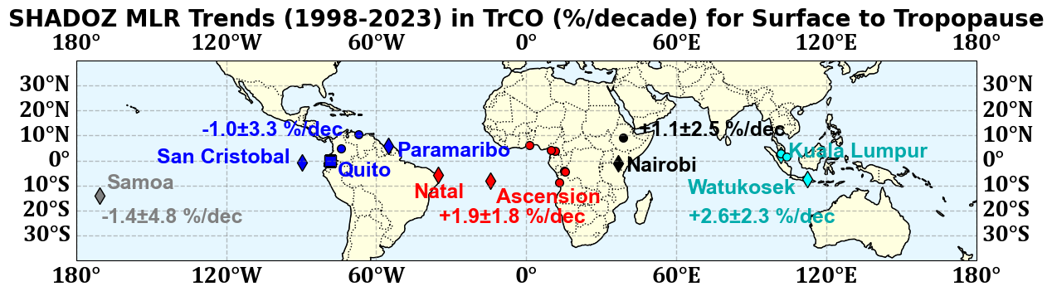

Figure 9. Summary map of the annual 1998-2023 MLR trends for five T21 SHADOZ sites for the total tropospheric column ozone (TrCO), surface to tropopause, in %/decade from Table 2 including the 95% confidence intervals.

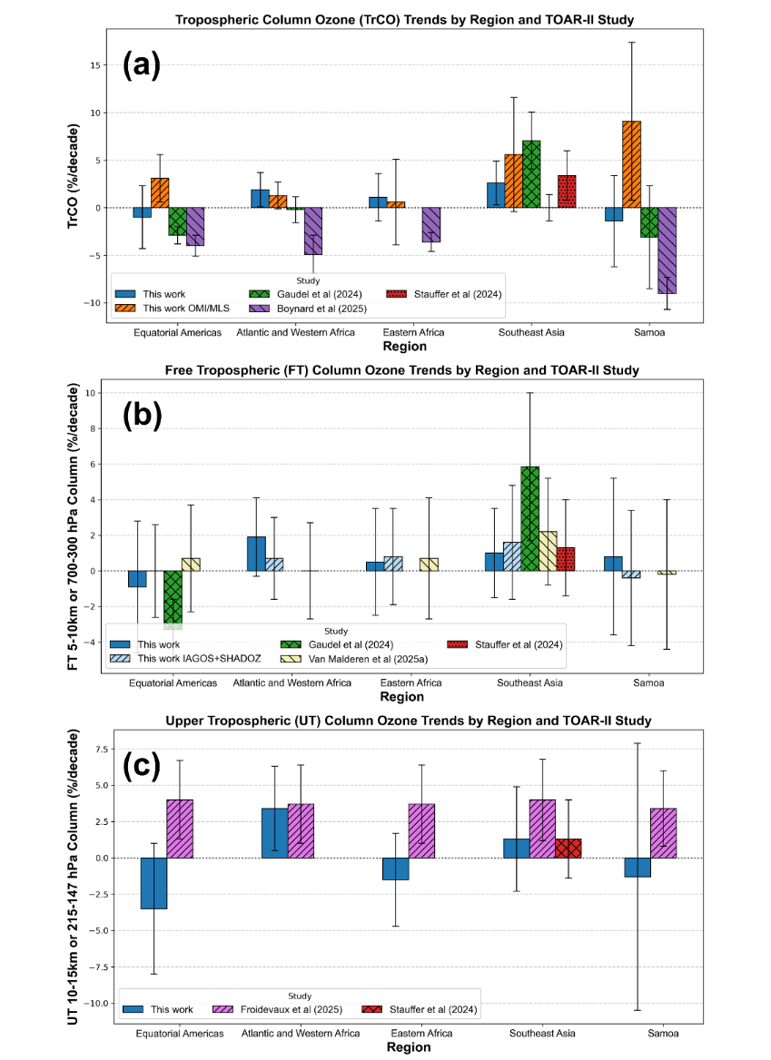
Figure 16. Summary of (a) TrCO, (b) FT, and (c) UT trends from multiple TOAR-II studies (detailed in Table 6). Trends are annual values in %/decade (sometimes estimated from each study); a different color represents each study across (a-c). Note that for trends in (a) and (b), periods differ somewhat: 2004-2019 in Gaudel et al. (2024; Fig. S25); 1998-2022 in Stauffer et al. (2024); 2000-2022 in Van Malderen et al. (2025a); 1998-2023 in This work. All are based on SHADOZ sondes and/or IAGOS. The satellite periods in (c) are 2005-2023 for OMI/MLS, This work; 2005-2020 for MLS in Froidevaux et al. (2025) and 2008-2019 for IASI from Boynard et al. (2025). Error bars show the 95% confidence intervals. If there are multiple values for a region in one study, a mean value is used.

