Summary
This is now a second review of the manuscript submitted by Lipp and Vermeesch. The authors have addressed many issues raised by the other reviewer and myself. They have significantly expanded the scope of the discussion and included examples of where the Wasserstein distance both works well and fails. This version is significantly improved over the previous one.

Recommendation
My remaining reservations with the manuscript address the underlying method of calculating the Wasserstein distance rather than its application as presented in the manuscript. With the exception of item 1 below, I think the manuscript could be published with minor revisions. I would like to see the authors address item 1 however,

General comments
- I maintain that the example in Figure 2 is problematic for both the KS and Wasserstein distances. As stated in the initial review, the translated distribution is most similar to the fixed distribution when their peaks align at ~900 Ma or 1100 Ma. When the translated distribution is centered at 1000 Ma, it shares no ages with the fixed distribution (albeit the tails of the distributions overlap). Nevertheless, both the KS and Wasserstein distances indicate that at this point the distributions are most similar. The authors have not addressed this problem either in their response or in the text. Surely at the very least, some explanation for why the behaviour observed in the KS and Wasserstein distances is desirable or intuitive is in order to justify using this example (or these metrics).
- I maintain that the absolute distance along the x-axis does not encode geologically meaningful information absent some context (c.f., the geologically meaningful information encoded by KDEs that can be extracted without reference to the geological context and therefore can provide independent evaluation and verification of geological hypotheses (Sharman and Johnstone, 2017)). See comment on line 168.
- Due to the need to select a metric based on an expected outcome, as the authors suggest, I wonder if this whole enterprise does not descend into circular logic. In other words, the metric is chosen because we expect a certain conclusion and (lo and behold!) the method confirms that conclusion. Does this return the detrital geochronology/thermochronology back to the realm of subjectively assessing each distribution, even if we then represent that the subjective analysis that we conducted using “objective” metrics?
- Is there an internal check that would provide an assessment of whether the selected metric is successful? For example, for the data from Degraaf-Surpless et al. (2002), I calculated a stress of ~0.14 for the MDS using the KS D value which is pretty high. Does the Wasserstein distance provide a better transformation (realizing that comparing between different metrics when conducting MDS is quite tricky)?
- If the method chosen is dependent on the specifics of the dataset and a prior analysis of the dataset, do the numerical metrics have any potential to illuminate (i.e., uncover latent features of) the dataset? See comment below on line 155.

Detailed comments
Line 122: I recommend removing this discussion of linearity. This is really a function not only of the translation of the respective distributions, but also of the shape of the distributions themselves. In other words, translating a bimodal distribution past another bimodal distribution would produce non-linear results for the Wasserstein distance as well.
Line 153: I think further caveats are warranted here. I don’t think that the Wasserstein distance can be applied with certainty in all instances of identifying upsection trends in provenance changes. As one simple example, take the dataset below (from Smith et al. (2023)) where the Wasserstein distance fails to identify unimodal sample 1CCT3 as a unique population and instead lumps it in with the bimodal 1FCTC166. Counterintuitively the Wasserstein distance also places unimodes 2PCGT190 and 1DCGT243 closer to the bimodal cluster than other bimodal samples such as 1FCTC166, or even samples that share the same modes but in different proportions such as SJMT7. I realize that all of these metrics have their own caveats.
I think the take-away for me is that the caveats need to be clear and that the basis for calculating the metric needs to be to be appropriate for the task (geochronology in this case). The authors can address the first of these issues by adding appropriate text to the manuscript as it is. The second one forms the basis of my deeper concern as outlined in point 2 in the General comments.
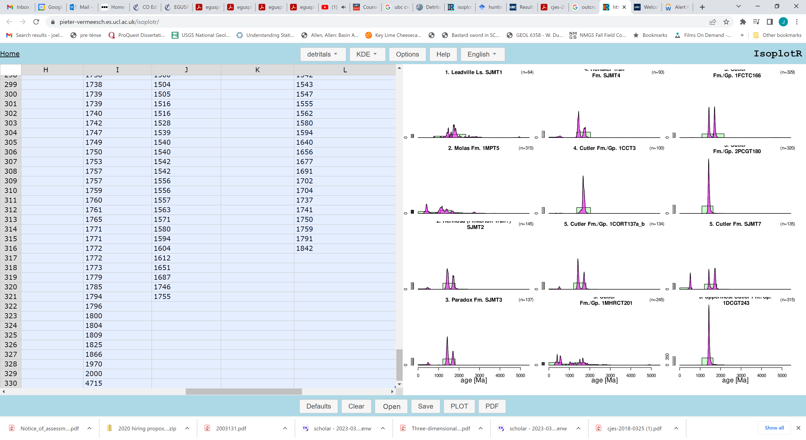
KDEs
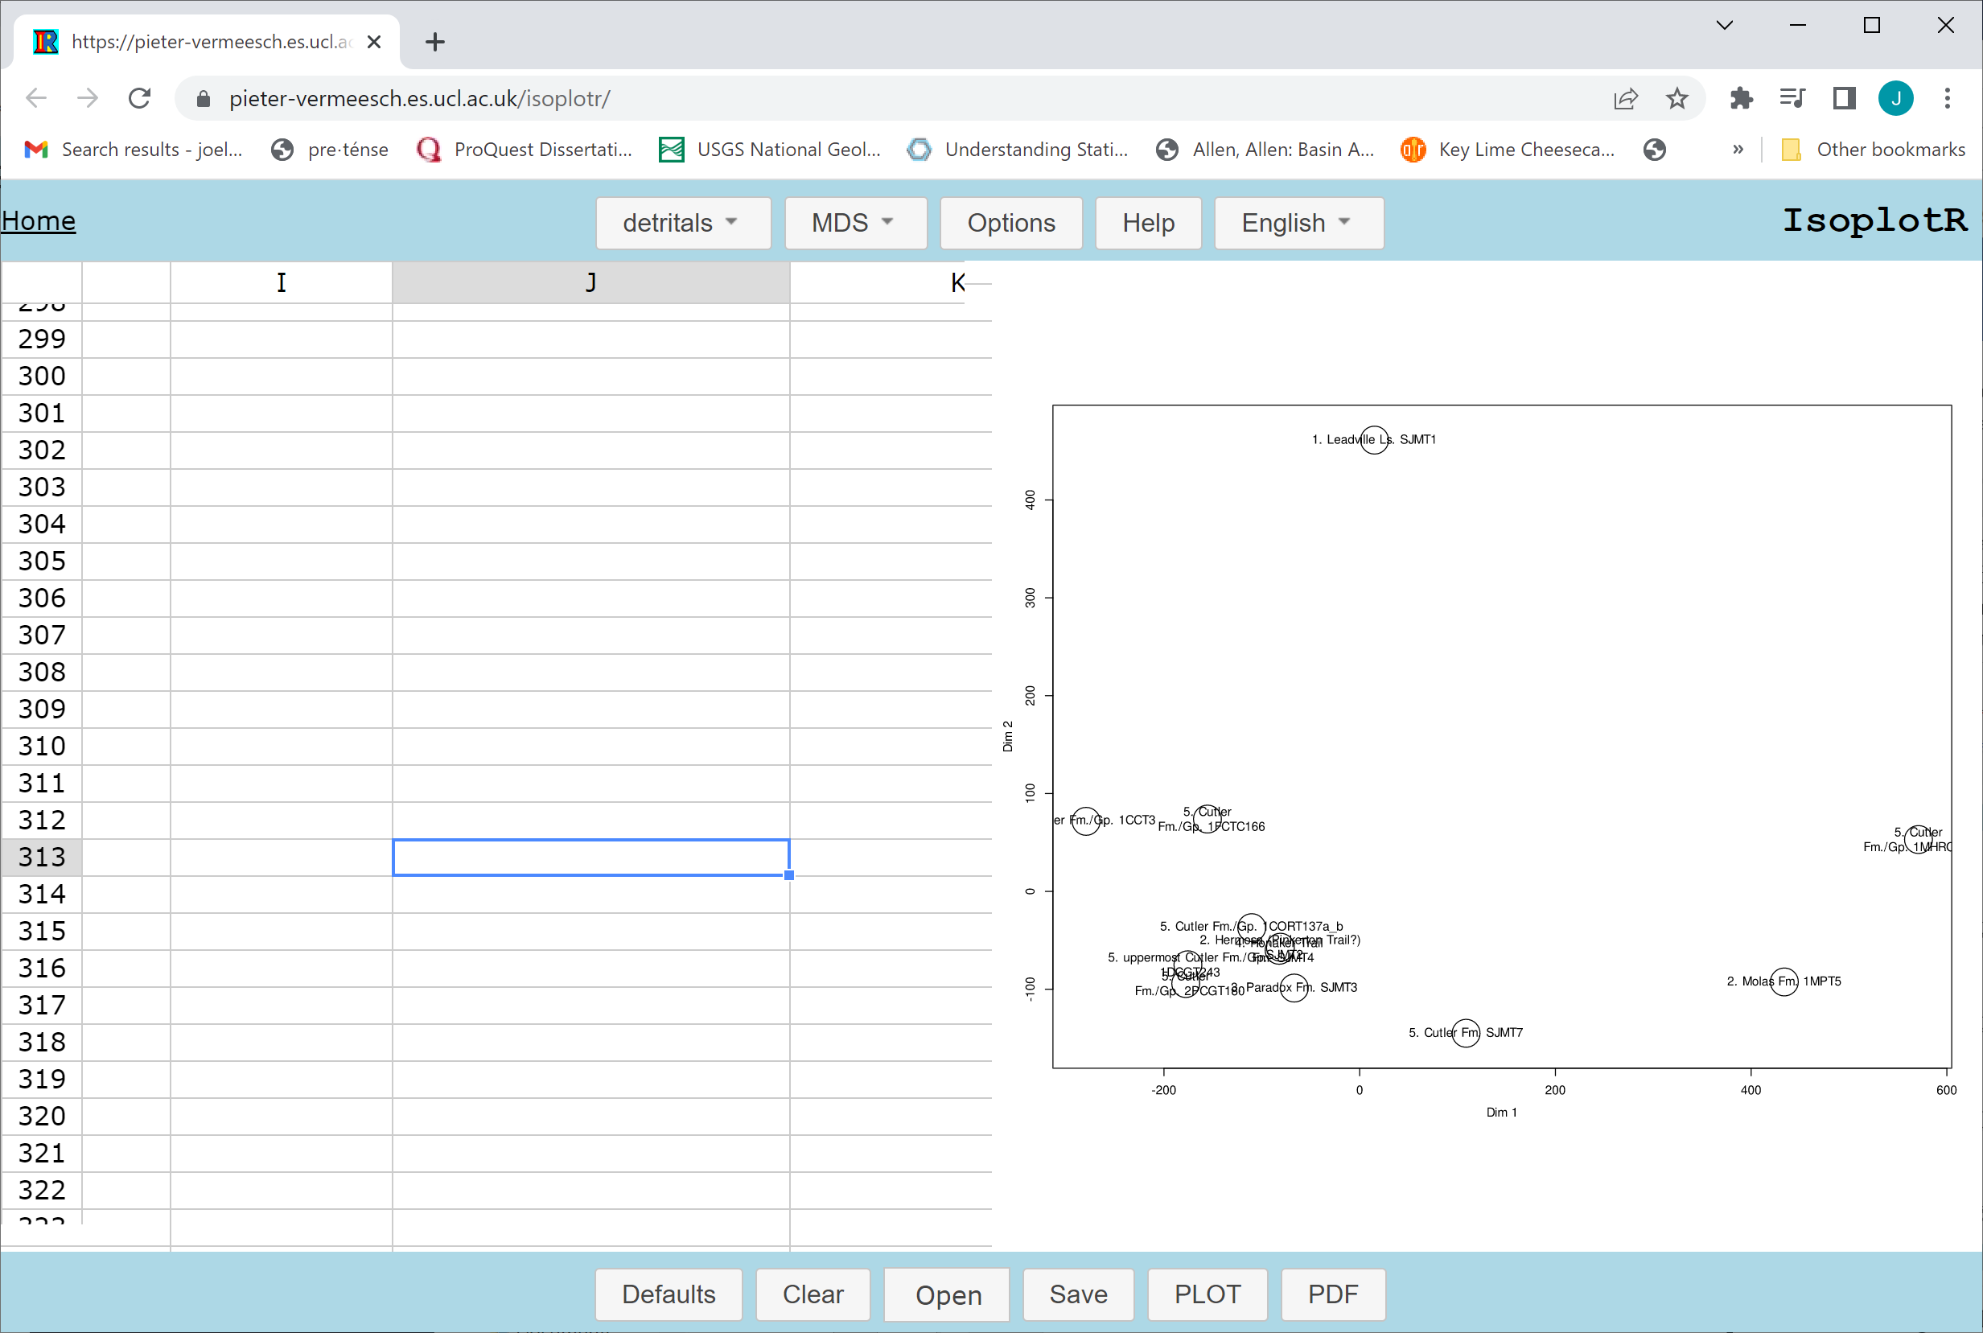
Wasserstein MDS

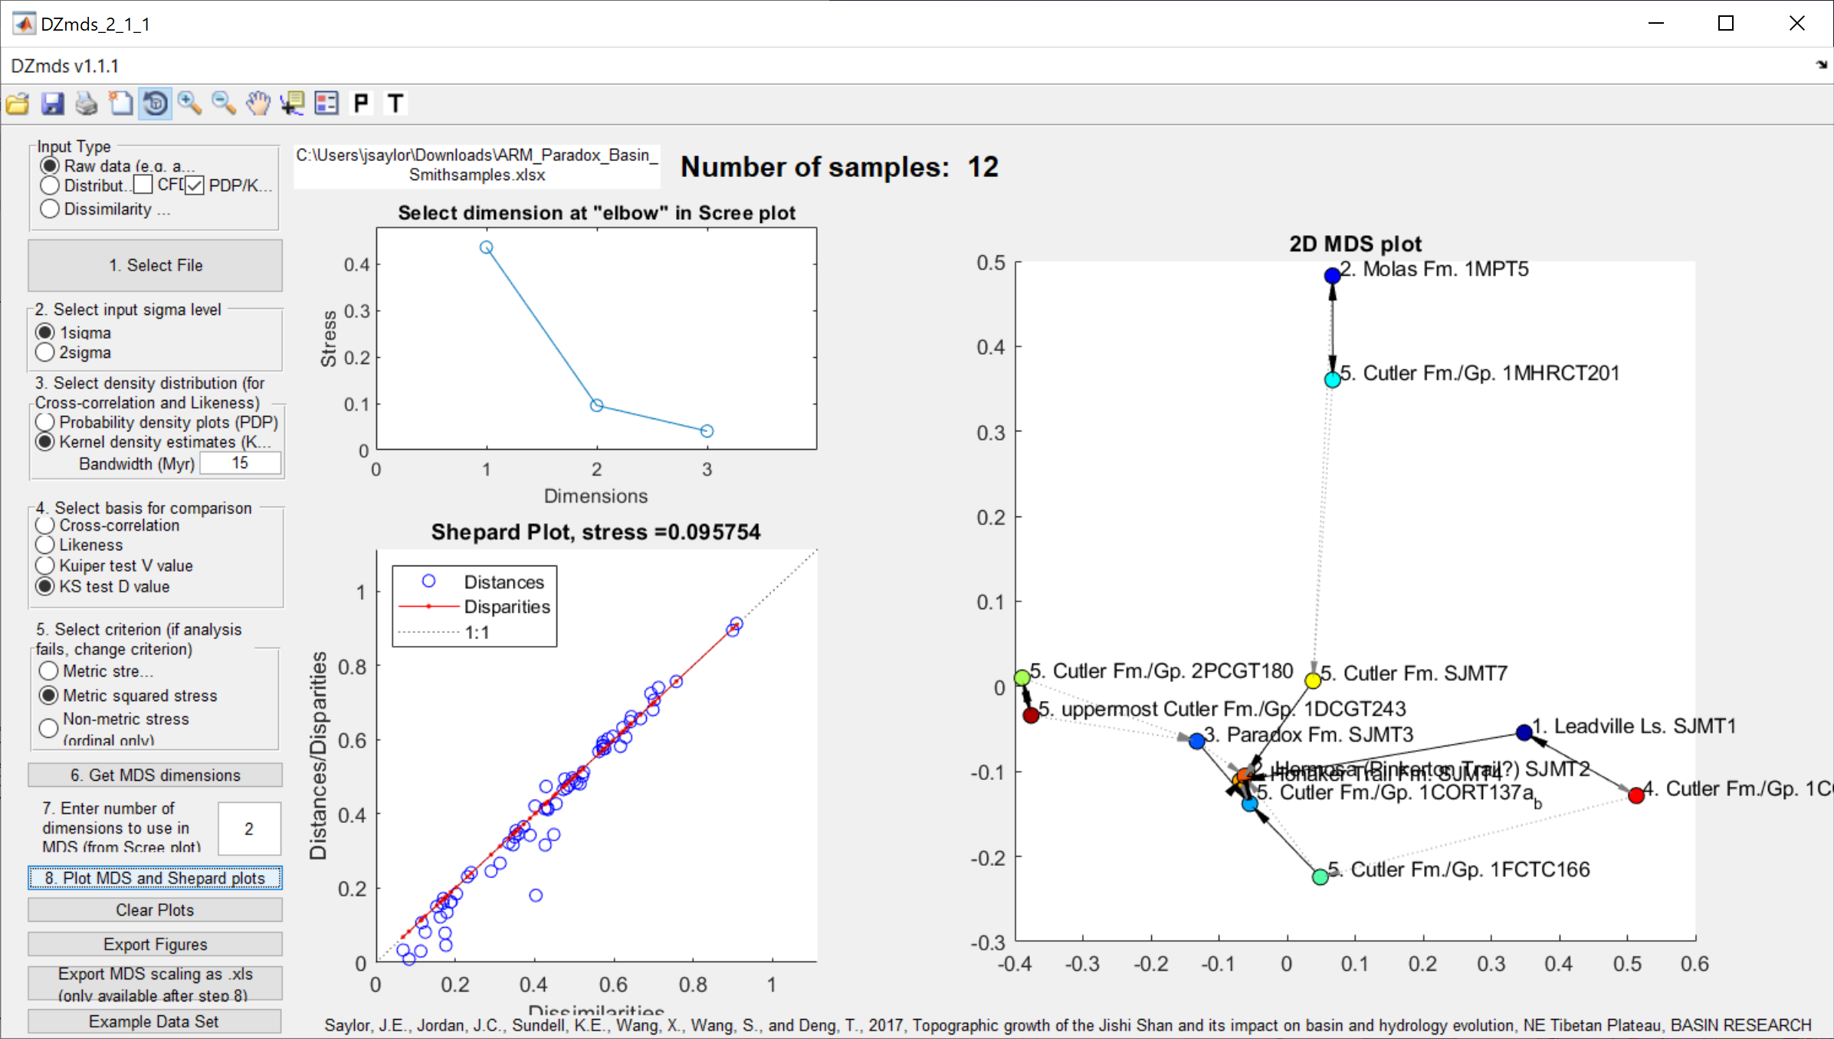
KS MDS

Line 155: MDS of the cross-correlation coefficient provides something similar to the Wasserstein distance. There is less clustering between GV-42, -45, -40, and -64 than with the Wasserstein distance, but otherwise it is pretty close. I am not necessarily advocating that the authors present this approach. Rather, I am presenting alternative approaches to consider which may illuminate the data or a way forward. 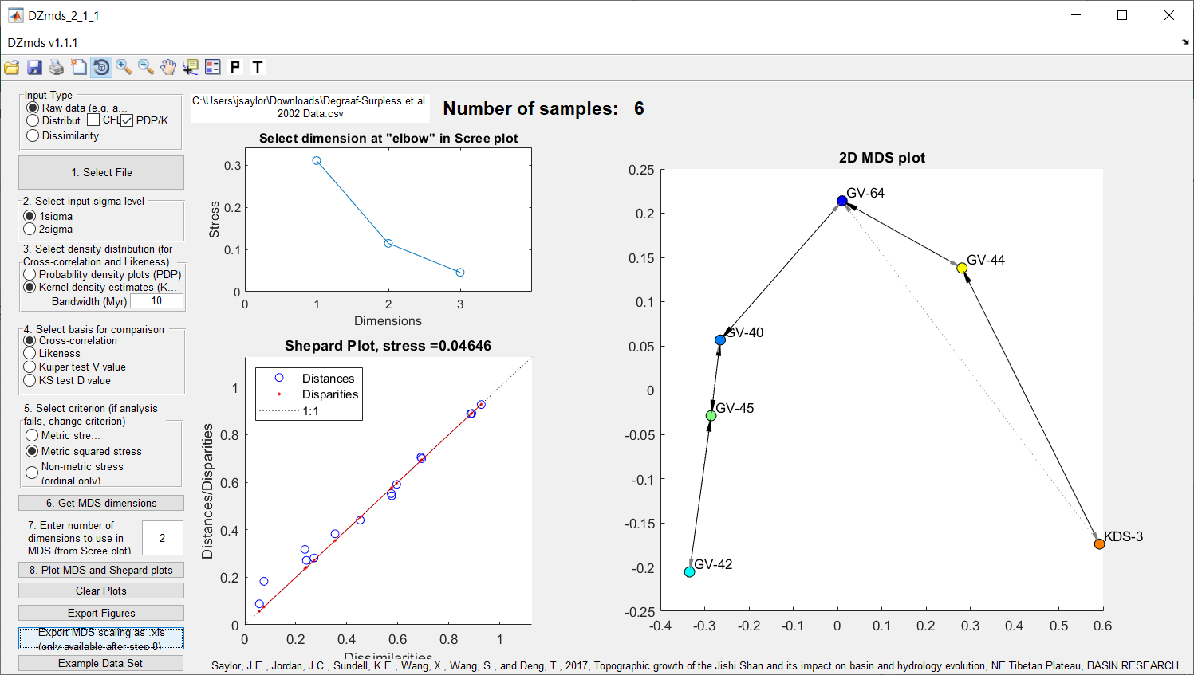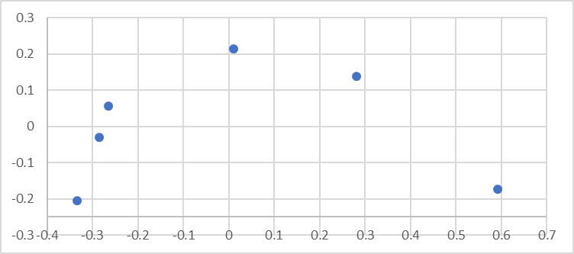
Line 160, 170: What are the stresses associated with these MDS plots?
Line 168: I disagree that the absolute distance long the time-axis provides any useful information here. The interpretation that there is a break in exhumation between WBS7 and WBS8 would be the same if the older samples had modes at ~100 Ma, instead of at ~1,000 Ma. The relevant information is whether there is significant overlap in age distribution between the northern 4 samples and the southern 4 samples. Beyond this, the comparison between samples is not meaningful. (Obviously, it changes the geological interpretation whether the southern four samples have age modes at 100 Ma or 1,000 Ma, but that is not a function of the intersample comparison. The four southern samples reveal their own geological history without reference to any other samples.

Works Cited

Sharman, G. R., and Johnstone, S. A., 2017, Sediment unmixing using detrital geochronology: Earth and Planetary Science Letters, v. 477, no. Supplement C, p. 183–194.
Smith, T. M., Saylor, J. E., Lapen, T. J., Leary, R. J., and Sundell, K. E., 2023, Large detrital zircon data set investigation and provenance mapping: Local versus regional and continental sediment sources before, during, and after Ancestral Rocky Mountain deformation: GSA Bulletin.

